***Lab1: Characteristics of the Basic Functional Circuit Blocks***

Name: Date: 2022-10-

Student ID: Location: SEIEE 4-402/404

Teammate:

***PRINCIPLES & OBJECTIVE***:

Operational amplifiers (Op-amps) are among the most widely used electronic devices today, being used in a vast array of consumer, industrial, and scientific devices. They are called “operational” amplifiers, because they can be used to perform arithmetic operations (addition, subtraction, multiplication) with signals. In fact, op-amps can also be used to integrate (calculate the areas under) and differentiate (calculate the slopes of) signals.

The objective of this lab is to study how to build the basic function blocks by op-amps, and study the static and dynamic characteristics of these blocks.

There are two important parameters that define the performance of a second order system. They are the damping ratio  and the undamped natural frequency . The change in value of of and will result in corresponding change of the settling time, the overshoot, and the amplitude of the transient response of a closed loop system. In other words, we can change the performance of the closed loop system by adjusting the these parameters. Keeping the remaining parameters unchanged, the value of and  can be adjusted by changing the forward path gain *K*.

The objective of this lab is to study the influence of the parameters on the performance of a given second order system by measuring the step response under different system parameters.

***EQUIPMENTS INVOLVED***:

1. Analog Discovery 2 (AD2), by DIGILENT from National Instruments (NI)

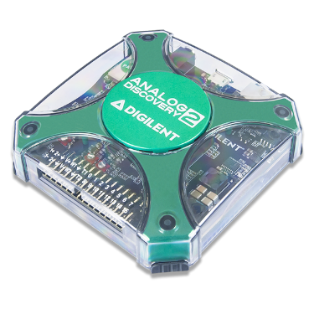

1. Waveforms, PC Virtual Instruments application by DIGILENT from NI

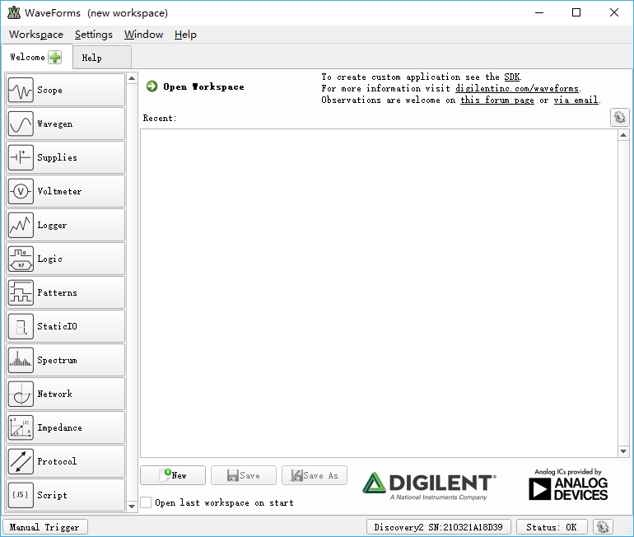

1. ACLab Experimental Kit

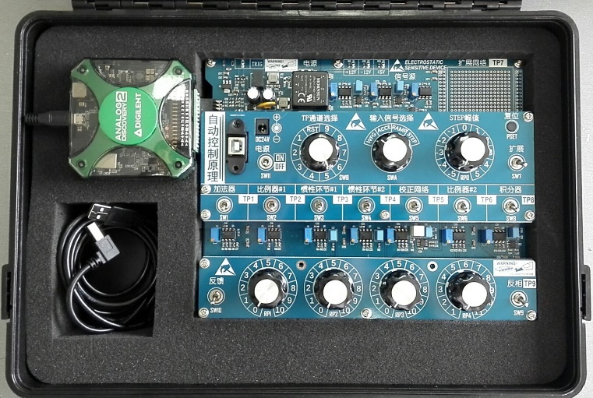

***PRE-LAB KNOWLEDGE***:

1. The fundamentals of operational amplifier analog circuits.
2. General operation skills on traditional instruments and virtual instruments.
3. Familiar with lab kit.

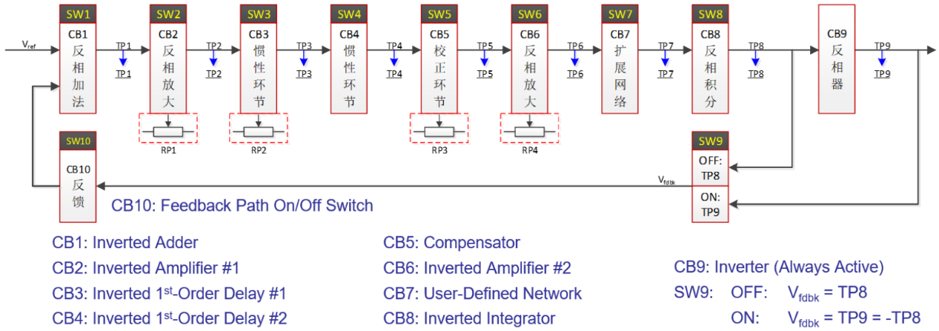

1. Understand the relationship between system performance and the parameters *ξ* and *ωn*.
2. Familiar with the computation of *K* from the given values of *ξ*.
3. Familiar with the calculation of steady-state error constants for different system type.

***PROCEDURE***:

1. Integrator with step input (Integrator SW8 ON; SWA: STEP; SWB: 9 (Inverter CB9 in use); AD2 SCOPE: CH2)

Configure circuit blocks properly for positive integrator circuit (The Inverted Integrator plus the inverter). Set step input amplitude properly (corresponds to RP0 scale), then run AD2/ SCOPE to observe and capture the response of the circuit at TP9. (RP0 scale at 1 or 2 will be OK)



1. Build a 2nd-order system according to the following block diagram, make sure it is a negative feedback system.



Circuit blocks in use：

Inverted proportional amplifier #1 *K*1

Inverted 1st-Order delay #1 ${K_{2}}/{\left(Ts+1\right)}$

Inverted proportional amplifier #2 *K*3

Inverted integrator ${K_{4}}/s$

(Please refer to the appendix of “ACLabKit User Manual.pdf” for detailed explanation of each circuit block)

1. The model can be presented in a form of generalized block diagram as below.

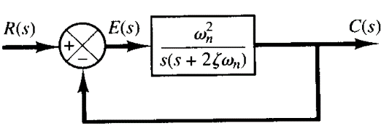

And the transfer function is：

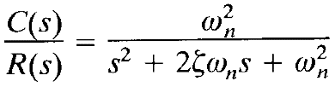

1. Transient response recording and analysis.

Set system parameters according to the following table, record the transient response under unit (or nearly unit) step input for each parameter combination. Measure and calculate *M*p, *t*s.

|  |  |  |  |  |
| --- | --- | --- | --- | --- |
| No. | RP1 Scale | RP2 Scale | RP4 Scale | *M*p, *t*s |
| 1 | 5 | 5 | 6 |  |

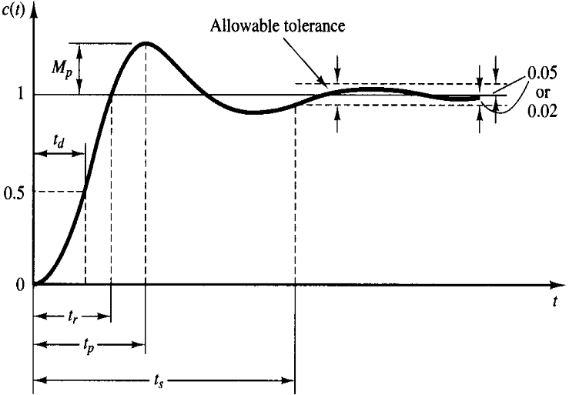

1. The circuit model built in previous step is a type 1 unity-feedback control system. The system type as well as the open loop gain *K* both has effect on the steady-state error under different input signals such as step, ramp and parabolic. Observe the impact of gain *K* on the steady-state errors under 3 different kind of input signals.

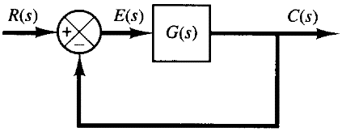 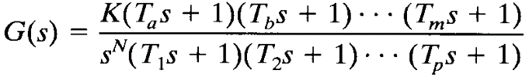

With the same parameters set in step 2), record the response under step, ramp and parabolic input. Test and verify the steady-state error in terms of gain K for a type 1 system, as indicated in the following table.

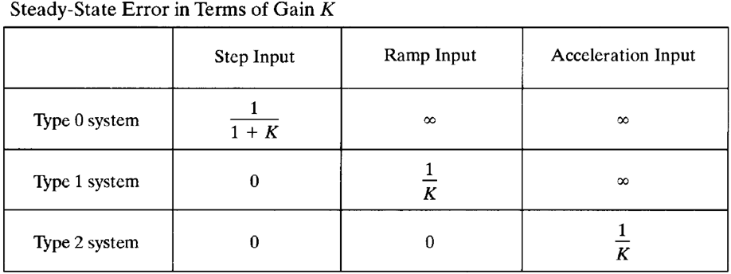

***RESULTS & ANALYSIS***:

1. Observe and record the results for the 1st question, calculate and analyze the transfer function of each circuit block with the specific parameters, compare and analyze the results from theoretical analysis and the experiment recording;
2. Derive the transfer function of the system you built in the 2nd question, measure the maximum overshoot *M*p and the settling time *t*s of the step response, record the transient response and compare it with the theoretical result. (You can use MATLAB/Simulink as tools).
3. Through the experimental results of the 3rd question, explain the ability of a type 1 system to follow position, velocity and acceleration inputs. Analyze the effect of open-loop gain on the steady-state error coefficient.
4. There could be deviations between the experimental results and theoretical analysis, please analyze the possible reasons that cause the errors.

***DISCUSSION***:

1. Under what conditions we derived the transfer functions of the op-amp circuit blocks used in this lab?
2. Under what circumstances can an inertial element/factor be approximated as a proportional element/factor, and under what conditions can it be approximated as an integral element/factor?
3. For two proportional amplifiers with gains of *K*1 and *K*2 connected in series, if we adjust *K*1 and *K*2 at will but keep their product unchanged, will we always get the same output?