***Lab2: Frequency-Response Analysis***

Name: Date: 2021-12

Student ID: Location: SEIEE 4-402/404

Teammate:

***PRINCIPLES & OBJECTIVE***:

The frequency characteristics of a complex system are usually determined from experiments and are expressed in form of amplitude-frequency characteristics curve M(ω) and phase-frequency characteristics curve φ(ω). Although the frequency characteristics experiment is rarely used in actual production, it is still the fundamental method for the study of automation control theory and the estimation of the transition process.

Measurement of frequency characteristics of automatic control system or component can use special equipment: ultra-low frequency characteristics tester (eg BT-6), whose measurement accuracy is relatively high, but the equipment is expensive. This experiment will use a more convenient way, namely Lissajous method, to measure it.

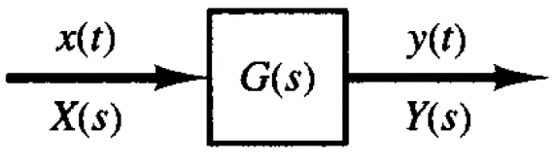

It is simple to measure the frequency characteristics: as long as applying a sine wave disturbance with certain frequency to the input end of the system, and then record the input and output amplitude. Change the frequency and repeat the above process several times. After the experiment, determine the amplitude ration of the output and input wave and the corresponding phase difference. At last, draw the figures according to the desired coordinates.

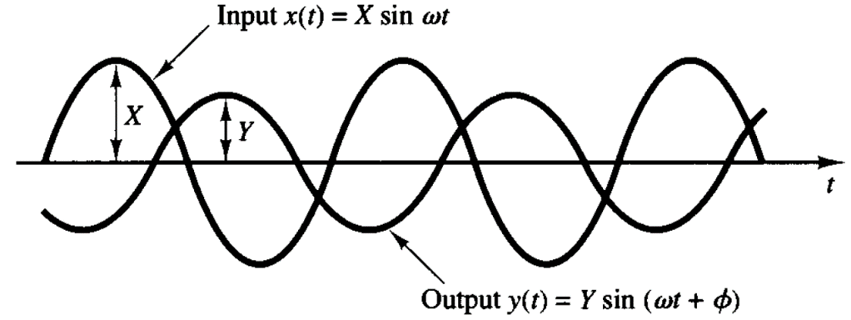

***PRE-LAB KNOWLEDGE***:

1. Familiar with lab kit operation
   1. How to switch ON/OFF a specific circuit block;
   2. How to select a specific signal source as input signal;
   3. How to select a proper test point for output signal observation;
   4. How to use AD2 virtual instruments functions with waveforms application.
2. Understand the concept of frequency response of a dynamic system
   1. Basic concepts of Bode diagrams;
   2. Bode diagrams for 1st-order/2nd-order/Integrator factors.
3. Familiar with the modeling for a given electronic circuit
   1. Schematic diagram for each circuit block;
   2. Transfer function for each circuit block;
   3. The inter-connection of different circuit blocks.

***LAB ASSIGNMENTS***:

1. **Frequency response of a 1st-order factor**
   1. Switch ON CB3 (1st-order inverted inertial factor#1) and CB9 (unity gain phase inverter), choose waveform generator as signal source (SWA set to WFG), observe output at TP9 (SWB set to 9), set RP2 value properly (refer to the description in the following c section).
   2. Run Network Analyzer from within the Waveforms application, set parameters for Start/Stop frequencies, Magnitude/Phase display windows properly, measure the Bode diagrams by clicking “Single” button.
   3. Based on the result from the previous step, adjust the circuit parameter (i.e. the value of RP2) or Network Analyzer display parameters if needed, so as to reflect the key features of the **DUT** (**D**evice **U**nder **T**est), i.e., for this 1st-order factor, the slopes at low/high frequencies and the corner frequency on the gain plot, and the phase angle varying from 0° at low frequency to -90° at high frequency on the phase plot. **NOTE**: a value too small for **Start** frequency or a value too large for **Samples** points will greatly increase the duration of a **Single** test, while a value too large for **Start** frequency could bypass the features of the DUT in the band of low frequency, and a value too small for **Samples** will definitely result in rough diagrams, you have to set these paramters properly.
   4. (Off-lab work) Refer to the sample Matlab code provided along with the lab#2 materials, build the transfer function model for the DUT, get Bode diagrams with Matlab.
   5. (Off-lab work) Compare the results recorded in step c) and d), give reasonable explanation for the possible mismatch between these results.
2. **Frequency response of an integrator**
   1. Switch ON CB8 (an inverted integrator) and CB9 (unity gain phase inverter), choose waveform generator as signal source (SWA set to WFG), observe output at TP9 (SWB set to 9).
   2. Run Network Analyzer from within the Waveforms application, set parameters for Start/Stop frequencies, Magnitude/Phase display windows properly, measure the Bode diagrams by clicking “Single” button.
   3. Based on the result from the previous step, adjust the circuit parameter (i.e. the value of RP2) or Network Analyzer display parameters if needed, so as to reflect the key features of the **DUT**, i.e., for this integrator, the slope is -20db/dec across low to high frequencies on the gain plot, and the phase angle close to -90° on the phase plot. **NOTE**: a value too small for **Start** frequency could bring the circuit into saturation, while a value too large for **Stop** frequency could result in a very low SNR and make the result erroneous .
   4. (Off-lab work) Refer to the sample Matlab code provided along with the lab#2 materials, build the transfer function model for the DUT, get Bode diagrams with Matlab.
   5. (Off-lab work) Compare the results recorded in step c) and d), give reasonable explanation for the possible mismatch between these results.
3. **Frequency response of 2 1st-order factors connected in series (an over-damped 2nd-order system)**
   1. Switch ON CB3 (1st-order inverted inertial factor#1), CB4 (1st-order inverted inertial factor#2), pluse an unity gain phase inverter in addition to CB9 (it could be CB1, or CB2 with RP1 set to 10, or CB6 with RP4 set to 1), with these configuration, the output we observe at TP9 is in phase with the input; choose waveform generator as signal source (SWA set to WFG), observe output at TP9 (SWB remains at 9), set RP2 value properly (refer to the description in the following c section).
   2. Run Network Analyzer from within the Waveforms application, set parameters for Start/Stop frequencies, Magnitude/Phase display windows properly, measure the Bode diagrams by clicking “Single” button.
   3. Based on the result from the previous step, adjust the circuit parameter (i.e. the value of RP2) or Network Analyzer display parameters if needed, so as to reflect the key features of the **DUT**, i.e., for this 2st-order DUT, the slopes at low/mid/high frequencies and the two corner frequencies on the gain plot, and the phase angle varying from 0° at low frequency to -180° at high frequency on the phase plot. **NOTE**: an improper setting for RP2 will make the two corner frequencies too close to each other; a value too small for **Start** frequency or a value too large for **Samples** points will greatly increase the duration of a **Single** test, while a value too large for **Start** frequency could bypass the features of the DUT in the band of low frequency, and a value too small for **Samples** will definitely result in rough diagrams, you have to set these paramters properly.
   4. (Off-lab work) Refer to the sample Matlab code provided along with the lab#2 materials, build the transfer function model for the DUT, get Bode diagrams with Matlab.
   5. (Off-lab work) Compare the results recorded in step c) and d), give reasonable explanation for the possible mismatch between these results.
4. **Frequency response of an under-damped 2nd-order system**
   1. Refer to the assignment 3) in lab#1, build a 2nd-order system accordingly (switch ON: CB1, CB2, one of CB3 or CB4, CB6, CB8, CB10), set values for RP1, RP2, RP4 properly, so that the DUT is under-damped (i.e. with a damping ration *ζ* smaller than 1, there will be oscillation in the step response).
   2. Choose waveform generator as signal source (SWA set to WFG), observe output at TP9 (SWB remains at 9); Run Network Analyzer from within the Waveforms application, set parameters for Start/Stop frequencies, Magnitude/Phase display windows properly, measure the Bode diagrams by clicking “Single” button; Based on the result from the previous step, adjust the circuit parameter (i.e. the value of RP2) or Network Analyzer display parameters if needed, so as to reflect the key features of the **DUT**, i.e., for this under-damped 2st-order DUT, there is a resonant peak value *Mr* at the resonant frequency *ωr* on the gain plot, and the phase angle varying from 0° at low frequency to -180° at high frequency on the phase plot. **NOTE**: with a value of *ζ* smaller but close to 1, the *Mr* will be very small and difficult to measure; a value too small for **Start** frequency or a value too large for **Samples** points will greatly increase the duration of a **Single** test, while a value too large for **Start** frequency could bypass the features of the DUT in the band of low/mid frequencies, and a value too small for **Samples** will definitely result in rough diagrams from which a correct value of *Mr* can not be read, therefore you have to set these paramters very carefully. Based on the measured value of *Mr*, determin the damping ratio *ζ* of the DUT.

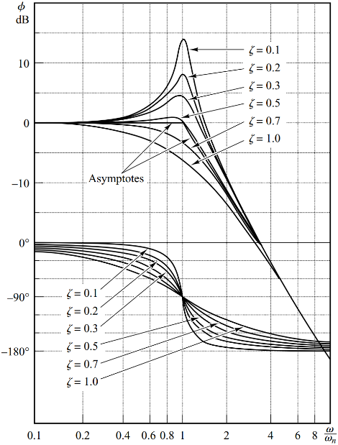 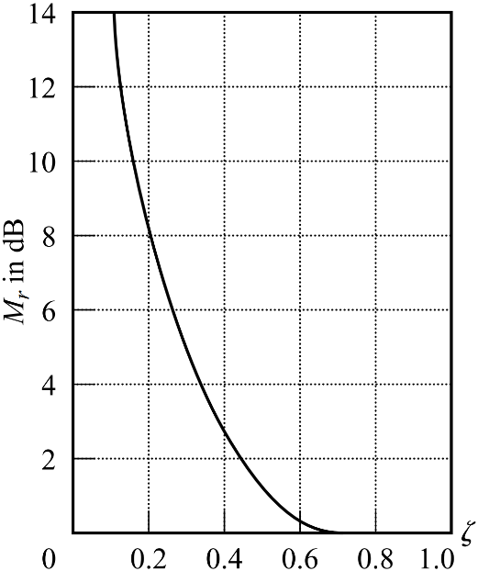

* 1. Refer to the operations of assignment 3) in lab#1, record the step reasponse of the DUT finally adjusted in the previous step, choose STEP as signal source (SWA set to STEP), observe output at TP9 (SWB remains at 9), press down and release RESET button to trigger a recoding scan. Based on the measured value of *Mp*, determin the damping ratio *ζ* of the DUT.

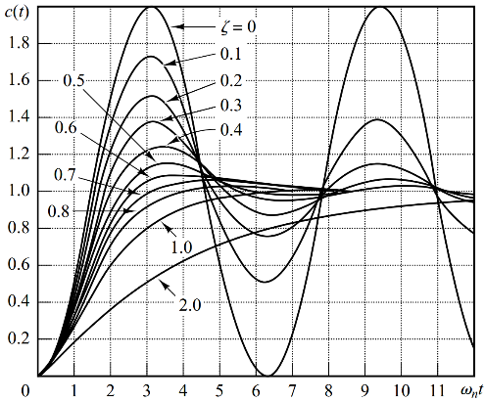 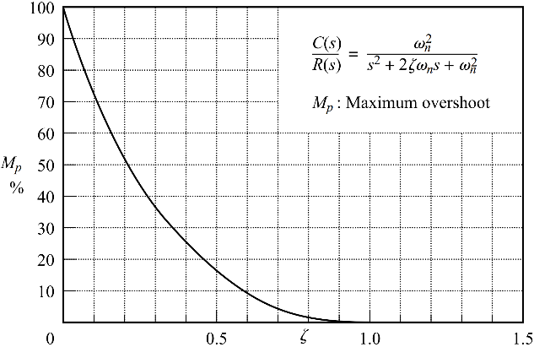

* 1. Within reasonable tolerance, the damping ratio *ζ* get from step b) should be the same as that get from step c). Compare the data, and explain the reasons that could cause the mismatch in your results.
  2. (Off-lab work) Refer to the sample Matlab code provided along with the lab#2 materials, build the transfer function model for the DUT, get Bode diagrams with Matlab.
  3. (Off-lab work) Compare the results recorded in step c) and e), give reasonable explanation for the possible mismatch between these results.

***LAB REPORT REQUIREMENT***:

1. Carry out all the operations described above in lab assignments, record the detailed results.
2. Make sure the recorded results are practically correct, make a reasonable explanation to any possible obvious non-ideal data.
3. Compare the recorded lab results to the results of digital simulation (you can use Matlab sample code for reference).
4. You may observe obvious difference between the Bode diagrams get by Lab and Matlab, especially at low frequency and high frequency band, make reasonable explanations to these differences. (e.g. The op-amp circuits could run into saturation at low frequency, and the amplitude of the output signal could be very small at high frequency, etc)

***DISCUSSION***:

1. In low-frequency range and high-frequency range, the measurement result could be different from that of analytical result. Please give reasonable explanations to these possible differences.
2. How to apply frequency domain experimental or theoretical analysis methods in practical applications?

***SUGGESTION and FEEDBACK:***

1. What is your opinion on the topic and contents of this lab?
2. Do you think it’s necessary to practice frequency domain analysis on hardware lab kit, or it would be better to use Matlab/Simulink only?

***REFERENCES***:

(If any)