***Lab3: Frequency Response and Series Compensation of a Linear System***

Name: Date: 2021-12-

Student ID: Location: SEIEE 4-402/404

Team member: Instructor:

***PRINCIPLES & OBJECTIVE***:

The performance of a feedback control system may not be satisfying if we only tune its stability properties. In this exercise, we are---apart from stability--- also interested in a compensation of the original feedback control system. In practice, we may design various types of compensators. Here, the purpose of introducing a compensator is to change the distribution of zeros and poles as well as the trajectory and the shape of the frequency characteristics of the system by adding poles and/or zeroes. The aim is to not only meet accuracy and stability requirements by designing open-loop gains, but also ensure ideal transient responses. The objective of this lab is to study the influence of the parameters on the performance of a given second order system by measuring the step response under different system parameters.

The objective of this lab is to study the frequency domain method to analyze the dynamic characteristics of feedback control systems, and study the compensation method using common compensation devices and learn about parameter tuning methods.

***EQUIPMENTS INVOLVED***:

1. Analog Discovery 2 (AD2), by DIGILENT from National Instruments (NI)
2. Waveforms, PC Virtual Instruments application by DIGILENT from NI

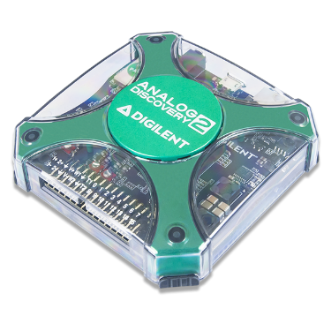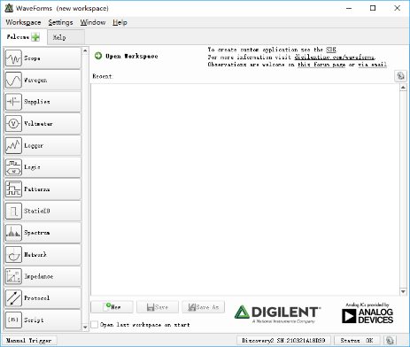

1. ACLab Experimental Kit

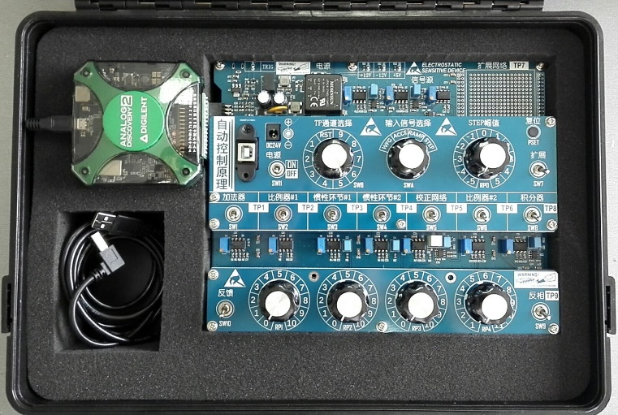

***PRE-LAB KNOWLEDGE***:

1. Understand the relationship between system performance and its Bode diagrams.
2. Familiar with the performance evaluation for a 2nd-order system from its step response.
3. Understand the transfer function deduction procedure for typical compensator circuits, like the phase-lead compensation circuit shown below,



The corresponding transfer function is,

$$W\left(s\right)=\frac{R_{18}+\left(R_{19}+RP_{3}\right)}{R_{17}}\left[1+\frac{R_{18}\left(R_{19}+RP_{3}\right){CI}_{5}s}{\left(R_{18}+\left(R_{19}+RP_{3}\right)\right)\left(R_{21}{CI}_{5}s+1\right)}\right]$$

While $R_{18}、{RP}_{3}≫R_{21}$, and in low frequency range, the TF can be simplified as,

$$W\left(s\right)=K\left(1+Ts\right)$$

Where,

$$K=\frac{R_{18}+\left(R_{19}+RP_{3}\right)}{R_{17}}$$

$$T=\frac{R_{18}\left(R_{19}+RP_{3}\right){CI}_{5}}{R_{18}+\left(R_{19}+RP_{3}\right)}$$

***PROCEDURE***:

1. By using virtual instrument ***WaveForms:Network*,** obtain the frequency response Bode plots of the series compensator CB5 with RP3 scale set to 10, and compare the result with theoretical analysis (Refer to ACLab3.m for computer simulation result).

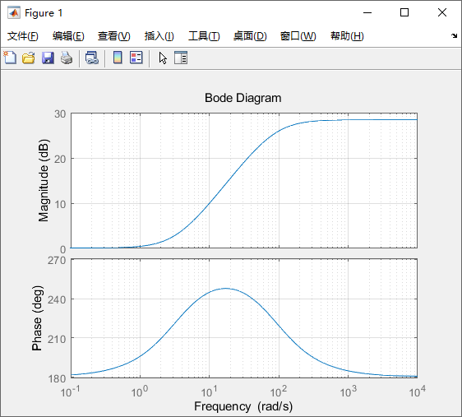

1. Build a 2nd-order system as shown below (using adder CB1, proportional amplifier CB2, inertial element CB4, proportional amplifier CB6, and integrator CB8), set scale of RP1 to 10, and scale of RP4 to 8. With a step input amplitude of 1V (set scale of RP0 to 2), capture the step transient response; measure and calculate *M*P and *t*s from scope display, compare the result with theoretical analysis (Refer to ACLab3.m for computer simulation result).



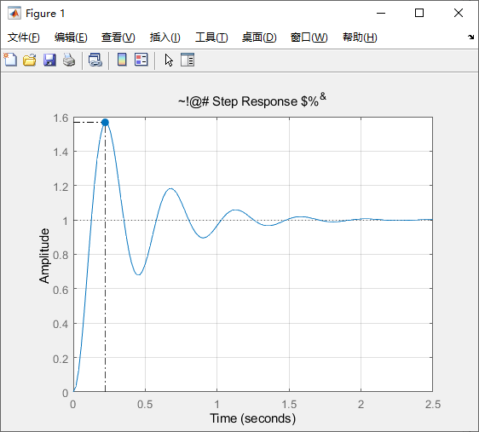

1. Insert the “series compensator CB5” into the 2nd-order system built above (switch-off the first proportional amplifier CB2, it is used to adjust the signal polarity in this lab session, so we can observe the output signal at TP9). Set the scale of RP3 at 10. Make sure that the circuit is connected as negative feedback. Capture the step transient response of this compensated 2nd-order system; measure and calculate *M*P and *t*s from scope display, compare the result with theoretical analysis (Refer to ACLab3.m for computer simulation result).

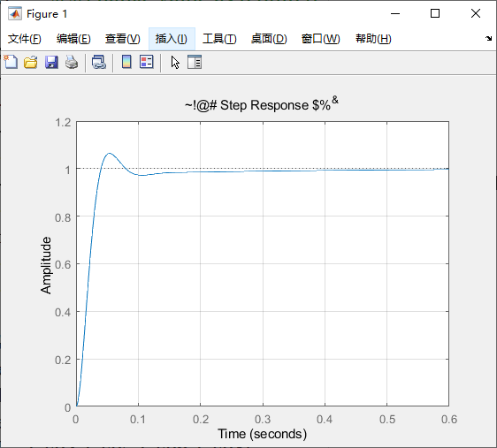

***LAB REPORT REQUIREMENT***:

1. Record the Bode diagrams for the compensator CB5, compare the result with theoretical analysis (you can use Matlab sample code for reference).
2. Record the step responses for the un-compensated and compensated systems, compare the result with theoretical analysis (you can use Matlab sample code for reference).
3. Explain how the phase-lead compensator CB5 effects the performance of the system.

***DISCUSSION***:

1. What are the basic characteristics of phase lead, lag, and lag-lead compensation?
2. What are the pros and cons of active compensation and passive compensation, respectively?

***SUGGESTION and FEEDBACK:***

**(This part is used to improve the lab course, it has no effect on report grading)**

1. What is your opinion or suggestion on the topics and contents of this lab?
2. What is your opinion or suggestion on the supporting platforms? such as online appointment system, functional blocks modularized lab kit, etc.
3. Any other issues related with the lab course.

***REFERENCES***:

bode(sys1)



bode(sys2_OL)

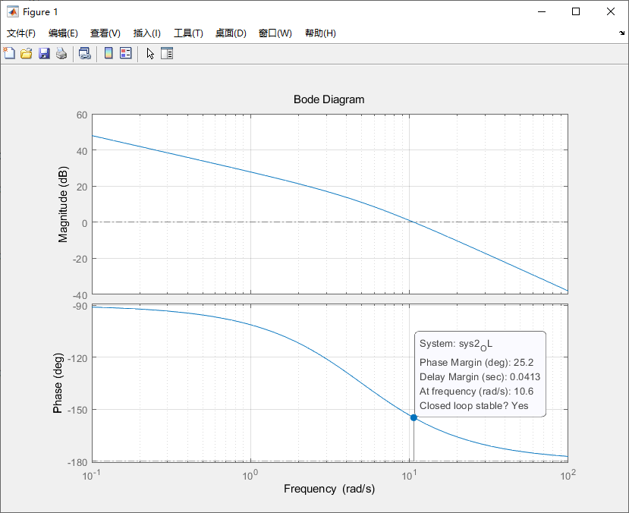

bode(sys3_OL)

