ACLab#3 Guidance for Online Students

**Pre-lab Works：**

1. Study and get familiar with the lab kit（**ACLabKit User's Manual**.pdf）
   1. Review the assignments for lab session #1 and #2；
   2. Get familiar with the block diagram of lab kit, know well the transfer function for each circuit block.
2. Read lab report template file（ACLab3实验**报告模板V2**.docx、ACLab3EN template V2.docx）
3. Install **Matlab** software
   1. Download the installation package from SJTU jBOX, release R2020b or R2021a are recommended.

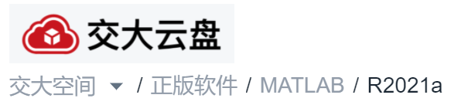

* 1. Install the software with at least the following options selected,

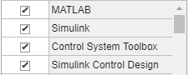

**Online Lab：**

1. Visit Lab webpage for lab materials, <http://autolab.sjtu.edu.cn/Data/List/zdkzyl>
2. Make appointment for lab#3 following the appointment instructions, only after this you can upload your report. (Online students are not required to attend laboratory course)
3. Download the Matlab sample code for lab#3 (ACLab3.m)
   1. Build Matlab models according to lab assignments, and finish all the tasks with Matlab.
   2. Finish lab report as required.
4. Upload report in time（[**http://autolab.sjtu.edu.cn**](http://autolab.sjtu.edu.cn)）。
   1. You have to make appointment first, then you can find the upload entry on the appointment page.
   2. Upload the report before the deadline, as indicated on the appointment page.